Building Trust and Relationships
Through Sharing Life Stories

2011-2012 Activities

A report about the work of Elad Vazana (eladvazana@gmail.com)

A report by Natasha Biran (natashaesther3@gmail.com)

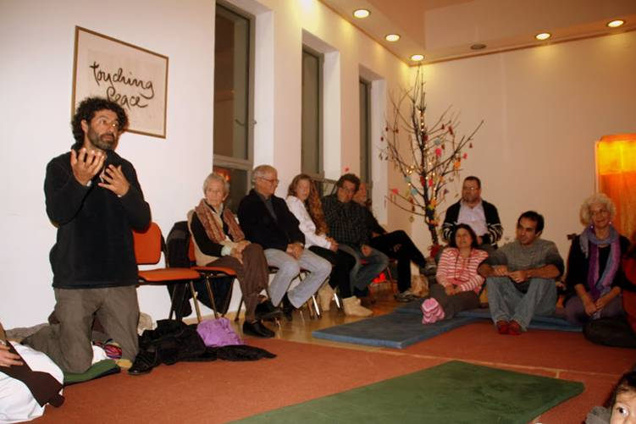

"An enemy
is one whose story we have not heard."
Ms. Gene Knudsen Hoffman

Life stories humanize the "other"
Hearing personal narratives
of our diverse backgrounds
brings us closer together.
Listening and being truly heard
is one of the great acts of welcoming
and community building.
This new quality of communication
awakens empathy and trust in the listener.
It heals the story teller.
It dignifies both.

L. Traubman

מסע - مسار -Journey
Arab - Jewish Leadership Workshop- empowering the young leaders of today
December 14-15-16 / 2012

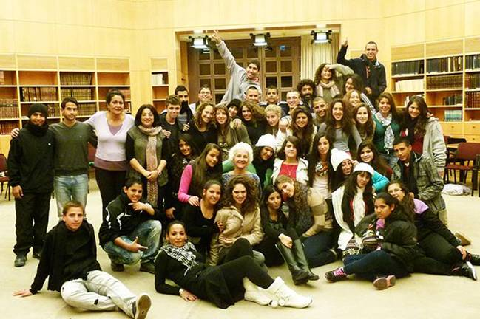
This was a 3 day gathering for 40 Jewish, Muslim and Christian youth, ages 15-17.

Two more days are planned in the upcoming months- one will consist of education about human rights and the other will involve visiting Bedouins in the Negev.

Following is an extract from a report (written after the Workshop) about an aspect of Elad's involvement in the Leadership Workshop.

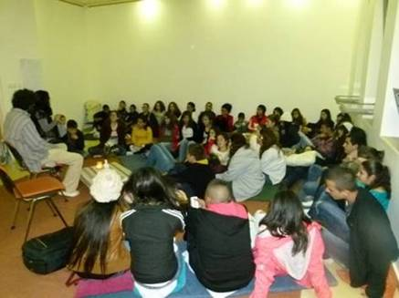
"On the evening of the first day of the workshop, Elad facilitated a life stories evening, where in an atmosphere of quiet respect, the participants were invited to share a story about their life in any way they wished, a story that has affected them in some way. Surprise was felt by all, as several members of the group opened their hearts sharing their innermost fears and experiences with their peers who they had just met that morning. This was testament to the unique environment that had been created throughout the day, and the evening served as a significant reminder of the human emotions that united the youth as one. Tears were shed for the suffering of others, without a second thought if the suffering was of a Jewish person or of an Arab." Natasha Biran

A Multicultural Curriculum for Students with Special Needs
Working with 8 youth and a School staff of 50 people
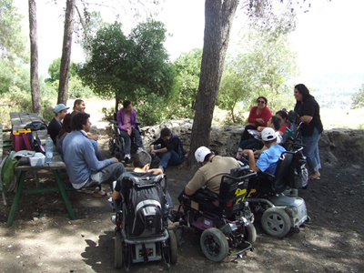
The age range was mostly 15-17 year olds and was for students with higher cognitive abilities. There were four Jews, two Arabs and one Armenian Christian in the class.

The staff at the school is diverse; it consists of native Israeli Jews, secular and orthodox Arabs, and people who have made Aliyah from different countries (e.g. America and France). The curriculum, created and carried out by Elad consisted of 12 sessions.

Following is a summary of the curriculum by one of the staff volunteers, Shoshana Oppenheim.

''Bringing multicultural education to this 7-person classroom at Ilanot was invaluable to the students and staff involved. The students learned about different religions and communities which increased their respect for and closeness with their classmates. They also gained confidence by teaching their fellow students about themselves, an opportunity they rarely have. Furthermore, the students increased their community involvement, by visiting so many areas of Jerusalem, working with the bilingual school nearby to clean a forest, and by writing a letter to their school system. The staff learned how to teach a multicultural curriculum to a multicultural class peacefully and respectfully instead of avoiding such a fragile topic. Elad realized that his work on bringing together groups, on humanizing “the Other” does not only apply to adults or typically-functioning students. Adolescents with or without special needs can learn from each other and take away valuable knowledge that completely overturns their preexisting notions and perceptions.''
Rachel Dascal, a physical therapist and member of the staff said, '' Through the curriculum, students learn to talk about themselves with confidence and take pride in their backgrounds; realizing how important it is for their classmates to know about where they come from.''



Life Stories and Live Music Events
20 plus meetings for 20-100 participants (reaching a total of 1200 participants)
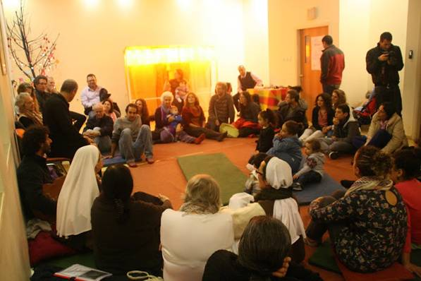
Elad's intention with sharing life stories is for it to be a way to build trust and build relationships. A number of the meetings took place in the spiritual center in Neve Shalom-Wahat al- Salam – Oasis of peace at the monthly gathering of the tribal fire (the Sulha Peace Project), an event which brings Israelis and Palestinians together. Other meetings took place in different institutes, schools, gatherings, conferences and other places.

Dafna Karta, the CEO of Hazon Halev said the following about Elad,
''Elad has a rare ability of leading and listening to individuals and members of the group whom he is with. His quiet and focused presence allows the meeting to be alive, floating and intimate, creating magical moments. People feel safe in this process.''

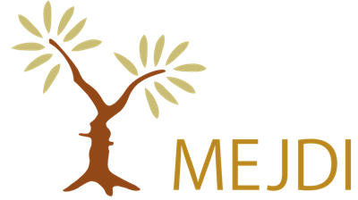

Middle East Justice and Development Initiatives
www.mejdi.net
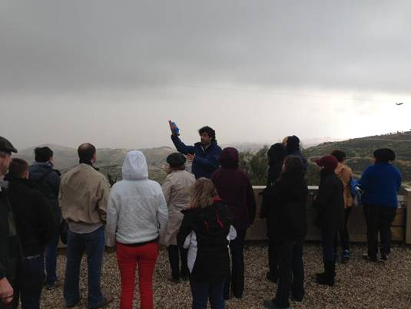
MEJDI is a joint Jewish-Arab tour operator that creates custom group tours to Israel, Palestine, Turkey, Jordan, and Egypt. Guided by a mission to provide responsible tour experiences and invest in the communities where they work, they provide clients with access to people and places that traditional tour companies cannot reach. As a result of this unique business model, their clients get to hear different perspectives, participate in new cultural experiences, and go behind closed doors to meet local religious, political, and tribal leaders.
Elad's work in the past year involved guiding six groups of tourists from the USA who came to learn about the Israeli-Palestinian narrative. The tours included meetings with settlers, refugees, ministers, journalists, peace activists and more. There were 20-30 participants per group.
Scott Cooper, one of the founders of MEJDI and Managing Director of the Center for World Religions, Diplomacy and Conflict Resolution wrote the following about Elad,
"Elad Vazana is one of the most effective yet humble peacebuilding practitioners in Israel. He has a natural talent for relationship building, for reflecting through his outer work all of the inner work that he is always doing to make himself a more effective agent of change."
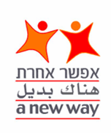

A New Way
www.anewway.org.il

About the program: Twinning and Coexistence
Through the pairing of Jewish and Arab classes (twinning), or through interventions designed for multicultural/mixed schools, mainly in mixed Jewish/Arab cities (coexistence programs), young people were exposed to the culture and narratives of the 'other'. Through joint, age-appropriate and extensive outdoor activities, music, drama, and sports, increased understanding and dialogue were fostered across ethnic, religious and cultural lines.
Currently this project is being facilitated in 36 schools all around Israel from north to south. The overall number of direct target groups is 3000 people.

Elads' involvement in this project is listed below:

1. Developing of a Manual for 30 group facilitators working with 3000 Jewish and Arab participants, for a program made up of 17 meetings. The developing process included more than 10 meetings for a group of facilitators learning together the needs and the goals of the manual and how to create it together. The result was the production of a manual (in book form) for the use of the facilitators accompanying them through all of the projects.

2. Training for 30 Jewish and Arab facilitators who are working with 3000 teachers, students and parents from more then 20 Arab and Jewish Schools all over Israel. This consisted of professional training for leaders, including professional assessments. Since the summer three courses have been held for professional facilitators of A New Way, in order to help them and to prepare them for the complicated work involved in the multicultural projects.
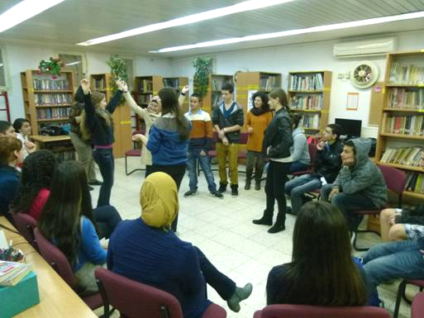
3. Leading of a project made up of a collaboration between the towns Abu-Gosh and Mevasseret Zion which extended its activity and welcomed the decision of the heads of the communities to establish a joint fund. This fund will be devoted to the continuation of the joint work and will encourage activities which promote cooperation between the sectors.

Dr Tikva Bracha, Executive Director of A New Way stressed the benefit of Elad's work with them,

"Under the leadership of Elad, we have passed through a deep proccess which by it we gain pedagogic and social tools which helps us alot in our multicultural work. Thanks to him, we became more professional, more Skilled and most significantly, more sensitive."

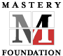
The School for Leadership
www.schoolforleadership.org

About the School for leadership in their own words:
Since 1983, the Mastery Foundation has existed to empower individuals and communities in their ministries, in the reconciliation and healing of divisions, and in creating new conversations and possibilities for the future, a future that would not otherwise happen.
In 2006, the Mastery Foundation began the process of developing the School for Leadership as a way of transferring our unique body of distinctions to the community and religious grassroots leaders we serve.
The School for Leadership is a living, adaptive structure that can both house and multiply the work and results begun by the founding generation of the Mastery Foundation, surpassing the difference already made through its transformational programs and networks of common commitment. The challenge is to do so in a way that is effective, affordable, and accessible.
Elad is a participant in The School of leadership of the Mastery foundation 3 year program. As part of this training he has had a coach for 3 years who he is receiving coaching from regarding all of the projects that he is choosing to create.
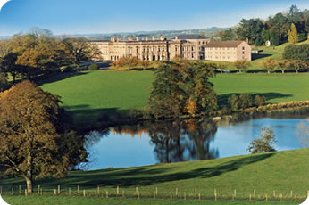
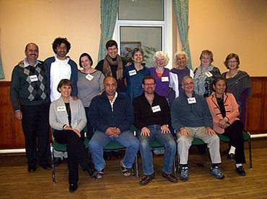

Life Stories and Activities Planned for 2013
Elad’s Vision: To create a world where people see each other as human beings. By the end of 2013 there will be a movement committed to awakening humanity among people in creative ways.
1. Life Stories meetings for diverse communities (12 meetings)
- 3 volunteers to help organize meetings
- 8 (estimated number) meetings for adults and 4 meetings for youth in schools
- Between 40 to 80 participants in each meeting (Average estimated total of 600 participants)

2. Youth leadership gathering (2 gatherings)
- For 60 Israeli and Palestinian youth from the age of 18-22
- 4 days gathering
- Youth from diverse backgrounds, e.g. Christians, Muslims, Jews (both Orthodox and secular) Settlers, Bedouins, Druze and more
- Focusing on encouraging the youth as leaders to create a world where people see each other as human beings

3. Training program for 15 Life Stories facilitators (6 meetings)
Train 15 facilitators to be able to initiate and facilitate Life Stories events and meetings.
- 6 training meetings planned for next year
- Each pair of facilitators will lead at least 1 meeting the next year
- Estimated total of 200 participants in Life Stories meetings from the trained facilitators

4. Development of the Facilitators Manual,
- Training for 40 dialogue facilitators who will work with more then 4000 participants starting in September 2013 (working with the new way)
- 5 training meetings planned for next year
- Expanding the Abu Gosh- Mevaseret Zion project to include 4 more schools
- Estimated total of 4000 participants

5. Sulha Journey to Switzerland
On May 31st- June 9th Elad will take 16 of the board and staff members of Sulha to Switzerland. The group has been invited by "coexistence" and the goal is to allow the core of Sulha- Israelis and Palestinians to spend quality time together, to know each other better. They intend to develop and deepen the understanding of Sulha's vision and goals for the future. They will spend time in the Swiss Alps, dedicating time each day for workshops and vision sessions. In the last evening the members from Sulha will facilitate a Multicultural and Multi Religious event for local Swiss people, with music, sharing stories and listening circles.

Contact Information:

Elad Vazana
Phone : +972 (0) 54 249 7009
Email : eladvazana@gmail.com
Web site : elad@havayati.co.il
Skype: eladvazana

